NATIONAL FLEET DATABASE

FLEET OWNER/MOTOR TRADER MANUAL

Table of Contents
FLEET OWNER/MOTOR TRADER MANUAL 1
1 Table of Contents 2
2 PURPOSE 3
3 National Fleet DATABASE (NFD)-Overview 3
3.1 UID 3
4 Fleet Owner Functionality Overview 4
4.1 Registering on the NFD Site 4
4.2 Updating my Fleet 6
4.2.1 Adding a vehicle 7
4.2.2 Removing a Vehicle 8
4.2.3 How to ensure your vehicles will not be stopped by the Gardai 9
4.3 Brokers 9
4.4 Printing Statements 10

PURPOSE
This document is a user friendly guide to help you the FLEET OWNER/MOTOR TRADER comply with National and European legislation, quickly, efficiently and at no cost. The Road Traffic Act 2010 requires details (registration numbers) of all motor vehicles insured in the State to be made available to the Minister for Transport. This is a user’s manual only but we would like to take the opportunity to emphasise to all fleet owners the importance of completing the requirements outlined below.

National Fleet DATABASE (NFD)-Overview
The NFD is designed to add fleet and motor trader registration numbers into the existing Automatic Number Plate Recognition (ANPR) system which already holds the registration numbers of all privately owned vehicles.
The NFD is a website (www.nfd.ie) for fleet/motor trader owners/managers to upload fleet registration numbers.
To upload your registration numbers you will need a unique identifier (UID).

UID

The UID is a unique identifier comprised of letters and digits used to identify your policy. Your broker/insurer will supply you with your UID and password for the National Fleet Database.

- IF YOU ARE ALREADY INSURED YOU WILL BE PROVIDED WITH A UID BY YOUR BROKER/INSURER.
- Brand new fleet/motor trader owners can register with the system first and inform the system of their vehicle registrations. You will not appear as insured however until you have been underwritten by an authorised insurer.

Fleet Owner Functionality Overview

Registering on the NFD Site
The first time a user goes to www.nfd.ie they must register on the site in order to update their personal information. They can do this by clicking on the “Not Registered? Click here to Register” link on the page, shown below.

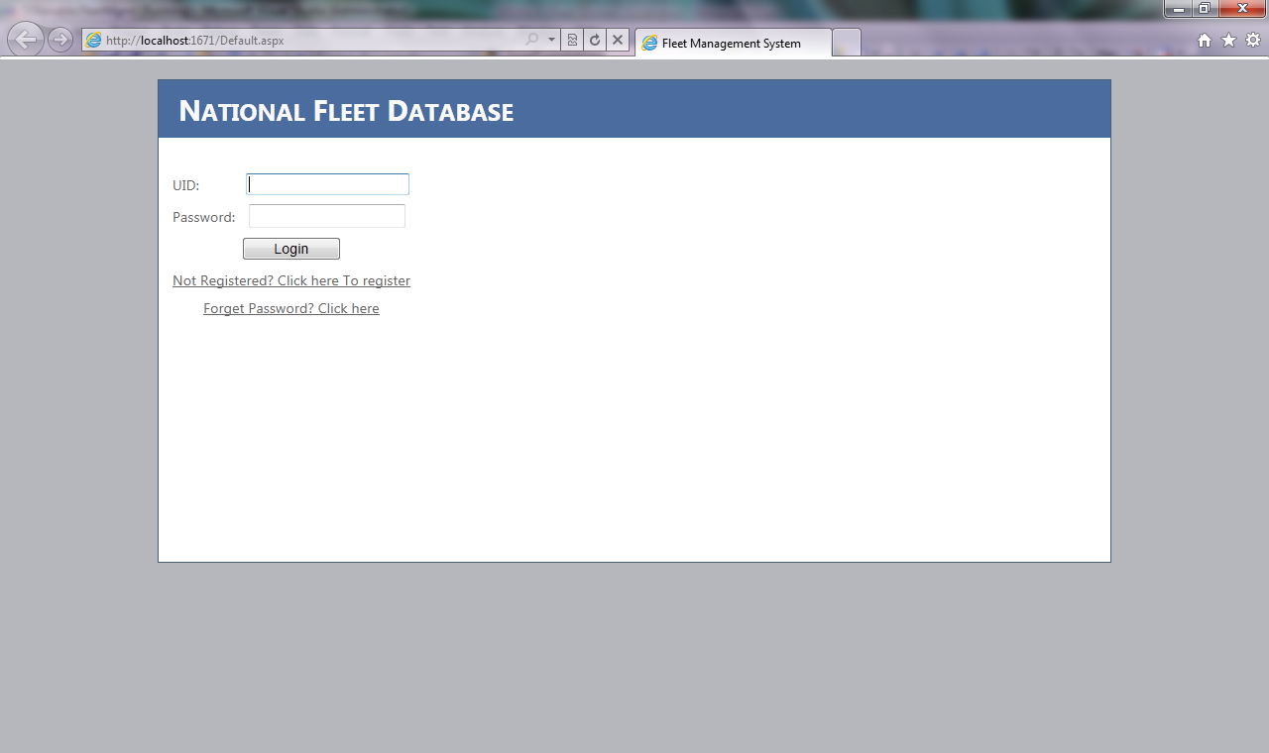

This will direct the user to the registration page shown in the following screen shot
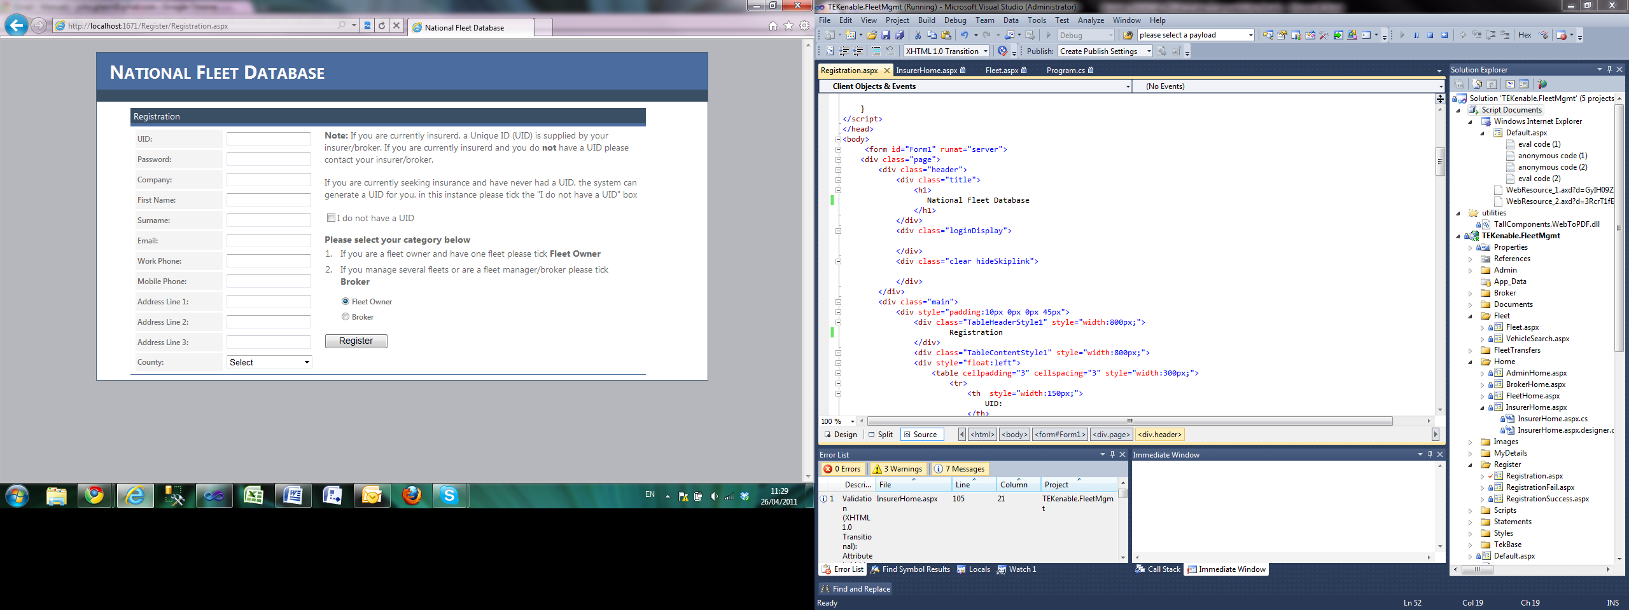

As a fleet owner/motor trader, you will have been issued with a UID and a password, please enter your details into the screen and click register. The following fields are mandatory:

- UID.
- Password.
- Company name.
- First name.
- Surname.
- Email.
- Work phone.
- Mobile phone.
- Address line 1.
- Address line 2.
- County.

If registration is a success then the following screen will be displayed.
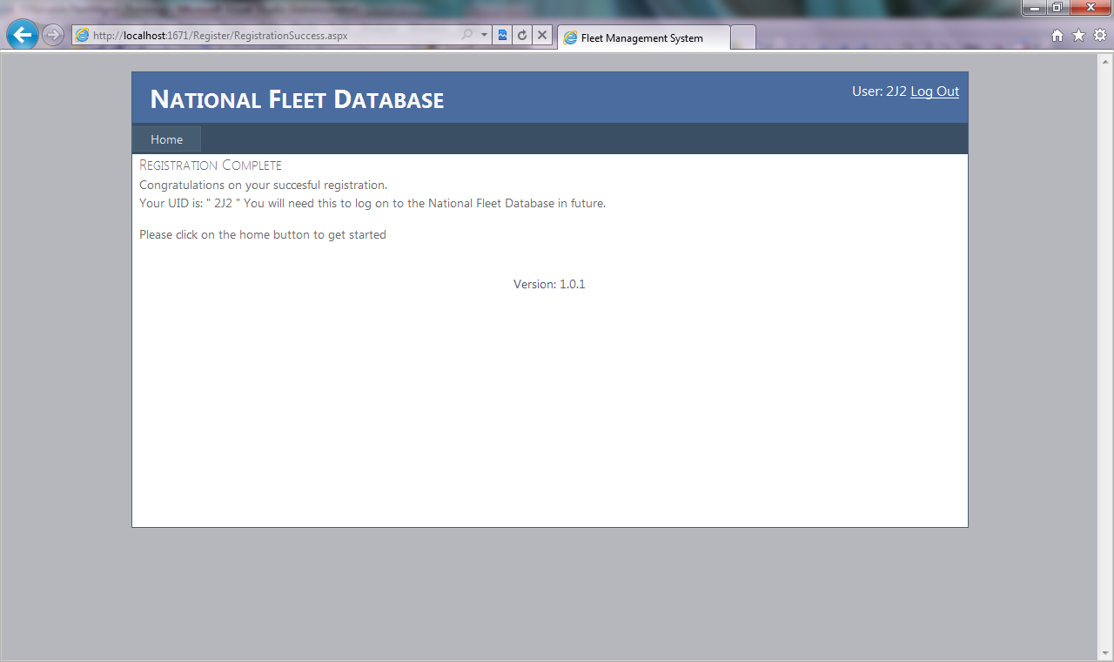
Clicking on the home button will direct you to the following screen.
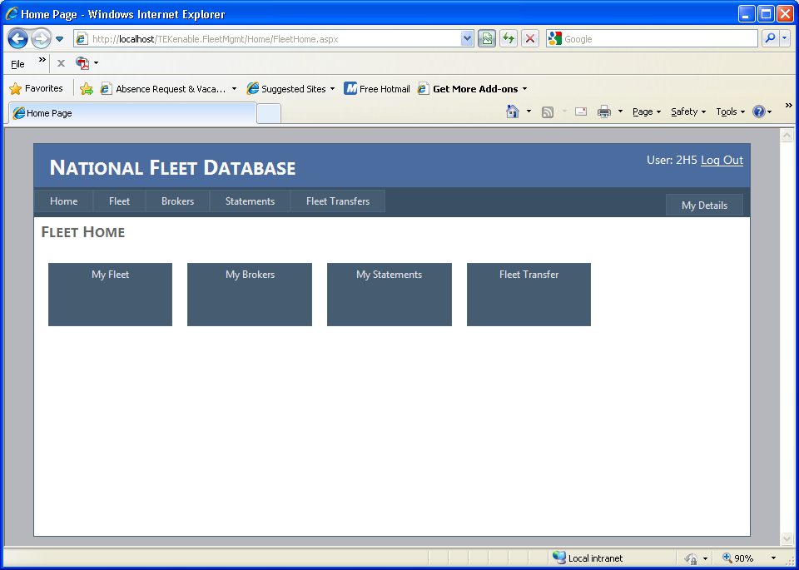
On the homepage you have four distinct options available to you:
- My Fleet: This section of the site allows you to enter, delete, and/or update your current fleet.
- Brokers: You can assign a maximum of two brokers to your fleet who can manage your fleet for you.
- My Statements: This section of the website allows you to print and/or download a statement containing details of your fleet over a set period of time.
- Fleet Transfer: You can if required transfer your entire fleet to another fleet using the UID of the other fleet or accept vehicles from another fleet.

Updating my Fleet
Once a fleet owner/motor trader logs on they will be directed to the homepage as previously mentioned, the user can update their fleet by clicking on the “My Fleet” option on the homepage. This will direct the user to the following screen.
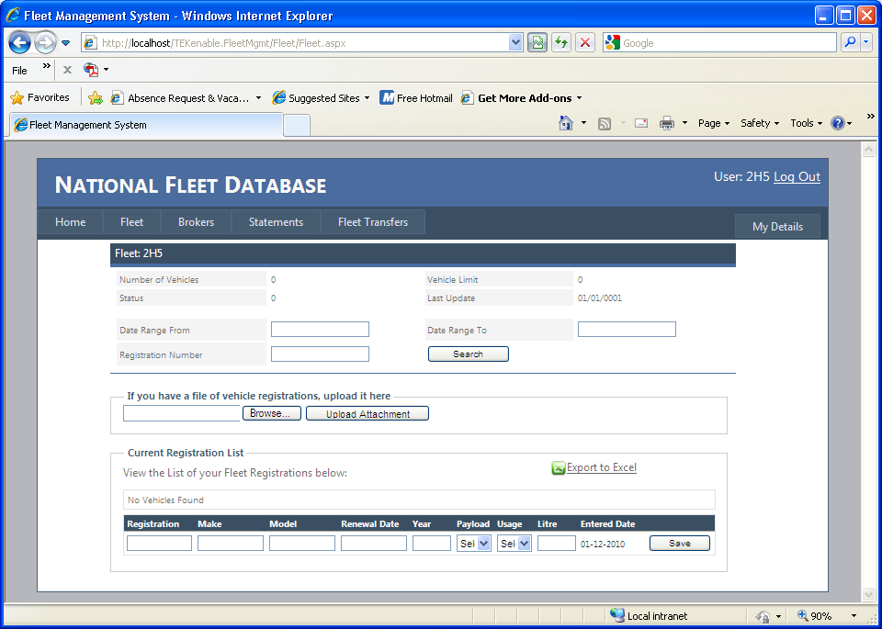

Adding a vehicle
From the “My Fleet” screen, the user can simply enter the details of a vehicle in their fleet under current registration list and click the “Save” button. Alternatively, the user can load a file of registration numbers in a ‘csv’ file format. The format of this file is simply a list of registration numbers as shown below. Only registration numbers should be provided when using excel list.
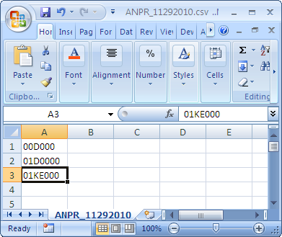
To save an excel sheet as a csv file click on “file -> save as” select other formats and select ‘csv’ format as indicated below. Once saved on your system, select browse in the fleet page on the NFD site and navigate to the location of the excel file. Select open, then select upload attachment – this will then populate the current registration list with the data provided in the excel spreadsheet.
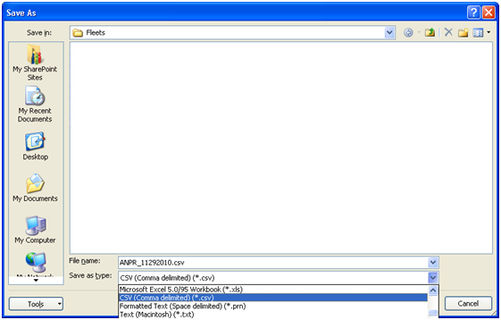

Removing a Vehicle
Removing a vehicle can be done by clicking on the corresponding “Remove” button in the current registration list. This will prompt the user to confirm they wish to remove a registration from their fleet as illustrated in the following screen.

It is recommended that you update the NFD whenever vehicles are added or removed from your fleet, or your custody or control as a motor trader. This will ensure your vehicles, or the vehicles you are responsible for are not stopped by the Gardai.
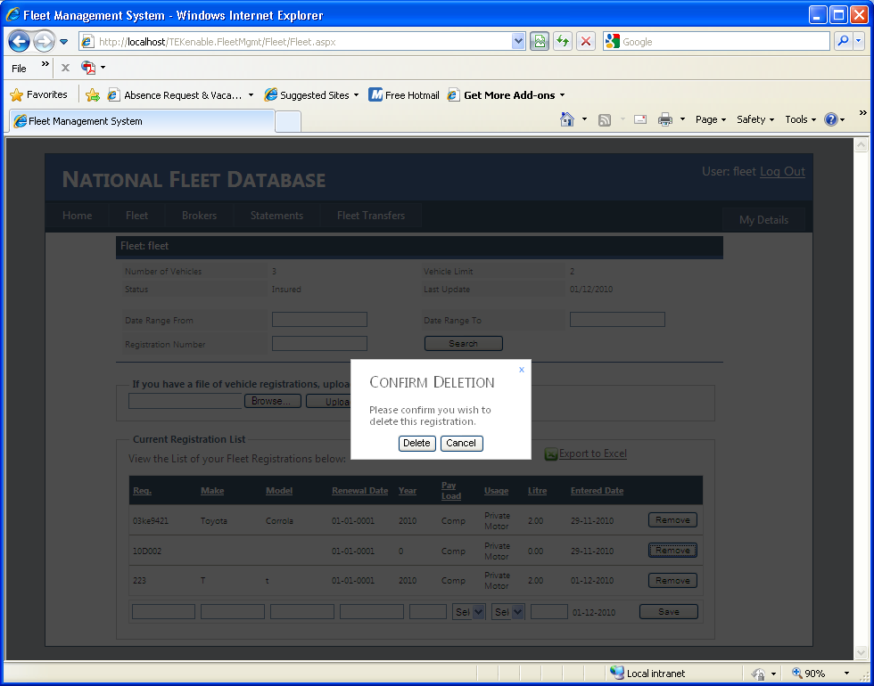
If you confirm the deletion of this vehicle then if will be flagged as uninsured by the NFD to the Gardai.

How to ensure your vehicles will not be stopped by the Gardai
- Make sure all your vehicle registrations are on the NFD.
- If you are insured your data will be automatically transferred to the Garda ANPR system once you have uploaded it to the NFD.
- If you are changing insurer or are a new fleet or motor trader you should inform your new underwriter of your UID and your data on the ANPR system will be changed automatically to reflect your new insurer. (It is important that you inform your new insurer of your UID immediately, otherwise your vehicles will be stopped by the Gardai)

NOTE
It is very important that you keep your fleet information up-to-date on the NFD so as to avoid business disruption such as:
- Having your vehicles stopped or impounded by the Gardai
- Being prosecuted under RTA 2010
Our recommendation is that as soon as you change even one of the vehicles in your fleet that you update the NFD that day. It will take you at most 2 minutes!

Brokers
If you wish to assign a broker to manage your fleet you can do so by entering the brokers UID into the textbox and clicking the “Assign” button.
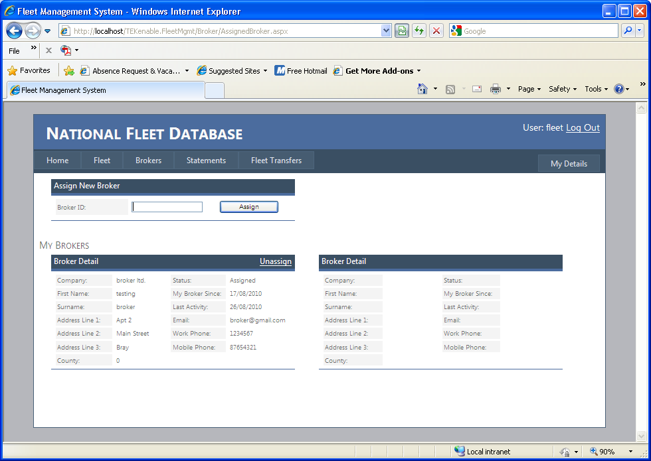

Printing Statements
The fleet statement screen allows you to view the history of your fleet, print and export this information.
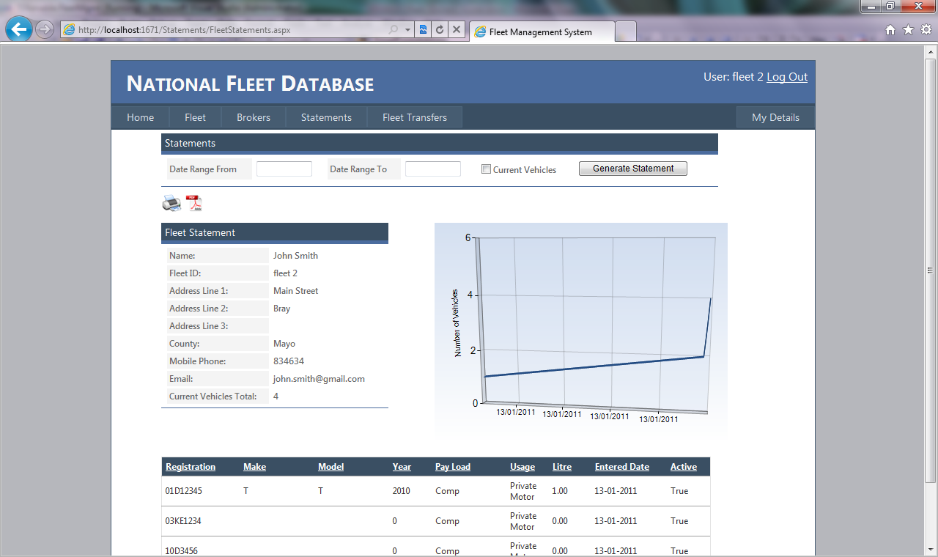
The grid shows the number of vehicles in your fleet over time while the table below the grid gives details of your vehicles.

